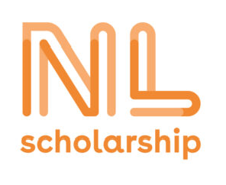
Request form NL Scholarship

The NL Scholarship is financed by the Dutch Ministry of Education, Culture and Science and Dutch research universities and universities of applied sciences. The scholarship is meant for international students from outside the European Economic Area (EEA) who want to do their bachelor’s or master’s in Holland. The EEA consists of the EU countries and Iceland, Liechtenstein and Norway.

Do you want to qualify for this scholarship? Complete this request form and hand it in at the secretariat before May 1st.

Pay attention: there are the following application criteria:

- Your nationality is non-EEA.
- You are applying for a full-time bachelor’s or master’s at one of the participating Dutch higher education institutions.
- You meet the specific requirements of the Theologische Universiteit Kampen | Utrecht.
- You have never before studied at an education institution in the Netherlands.

Annually, there is only one scholarship available for a future TUU-student. Therefore, the Theologische Universiteit Kampen | Utrecht will also take into consideration issues like:

- Your study results
- Your study tempo
- The coherence between your study abroad and in the Netherlands.

Full Name
Gender

Date of birth

Nationality

Contact details (phone-number, e-mailaddress)

Current study phase
(Bachelor/Master)

Study past (study tempo,
Content of subjects)

How long do you want to
stay in the Netherlands?
What courses/subjects do
you prefer to attend at the
TUU?

Please, tell us something about your motivation

