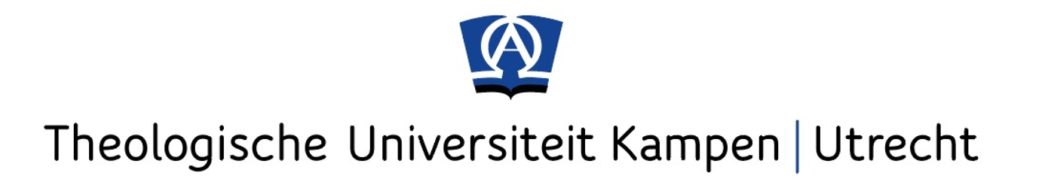
Advanced Theological Studies Fellowship
Application Form

Note: Read the instructions in this application form carefully for a successful application.

Personal information
Name (first, last):
Gender: M/F
Nationality:
Date of birth:
Current residential address:
Institutional affiliation (if any):
(Sub-)discipline of research:
Expected date of finishing PhD:
I will be available for the full duration of the programme: Yes/No

Proposal
General area of research:
Describe your PhD project in 150 words (max.).

Proposal for the ATSF:
Describe what part of your research you would like to carry out during your month in Kampen. Indicate how this relates to your broader research and why the ATSF would be a fitting place to do this research. Indicate which research programme of TU Kampen | Utrecht applies. Please include a prospective title for the paper you will present (250 words max.).

FYI: If accepted, you are expected to present your research and plans for the ATSF month during a poster presentation session at the beginning of the programme.
At the end of the month, you are expected to present the results of your research, esp. the part you focused on during the ATSF period.

Ecclesial affiliation
Theological University Kampen | Utrecht is a Christian, Reformed institution. The university and the ATSF programme welcome all Christian theologians. Yet, to make the most of the fellowship opportunities the programme presents, we do ask that you indicate how you relate to the Reformed-Evangelical character of our university (150 words max.).

Please:
- fill out this form completely
- attach your C.V.
- send this to international@tukampen.nl.

Strike through whichever is not applicable.
May 22nd -June16th, 2023. If no, unfortunately, we cannot accept your application. Please note that you are expected to on your own, to stay together with the other participants in the university guest house and that you cannot bring family members or others with you.

